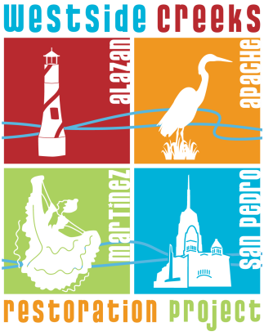
Agenda
Westside Creeks Restoration
Oversight Committee (WCROC) Meeting
San Antonio River Authority
100 E. Guenther
May 19, 2020
6:00 p.m.

- Welcome
  - Robert Ramirez & Skye Curd, Committee Co-Chairs

- Citizens to be Heard

- Calendar Items

  - San Pedro Creek Culture Park Yoga --- Yoga has gone virtual with Mobile Om!
  - San Pedro Creek Sub-Committee Meeting, June 11, 2020 9:00 A.M. GoToMeeting
  - San Pedro Creek Sub-Committee Meeting, July 9, 2020 9:00 A.M. GoToMeeting
  - San Pedro Creek Sub-Committee Meeting, August 13, 2020 9:00 A.M. TBD
  - Westside Creeks Restoration Oversight Committee Meeting, August 18, 2020 6:00 P.M. TBD

- Approval of Meeting Minutes, February 18, 2020

- Introduction of Arts and Community Complex on Apache Creek, Jon Hinojosa, Say Si

- Status Report on Westside Creeks Improvements Projects, Richard De La Cruz & Reuben Bazan, River Authority

- Status Report on San Pedro Creek Culture Park and Communications, Kerry Averyt & Monica Trevino-Ortega, River Authority

- Update on Public Art for San Pedro Creek Culture Park, Carrie Brown, River Authority
Public Participation: Public comments will be accepted after each agenda item after committee comments are complete. We ask that comments be limited to no more than three (3) minutes in length to allow adequate time for everyone to be heard.
Comments during the public comment portion are also limited to three (3) minutes and we ask that time not be transferred to another individual.

- Miscellaneous Items

- Adjourn

For additional project information visit:
www.westsidecreeks.com www.spcculturepark.com

